3 – BIRD FUN SHOOT
(SEMI AUTO/ PUMP ONLY)

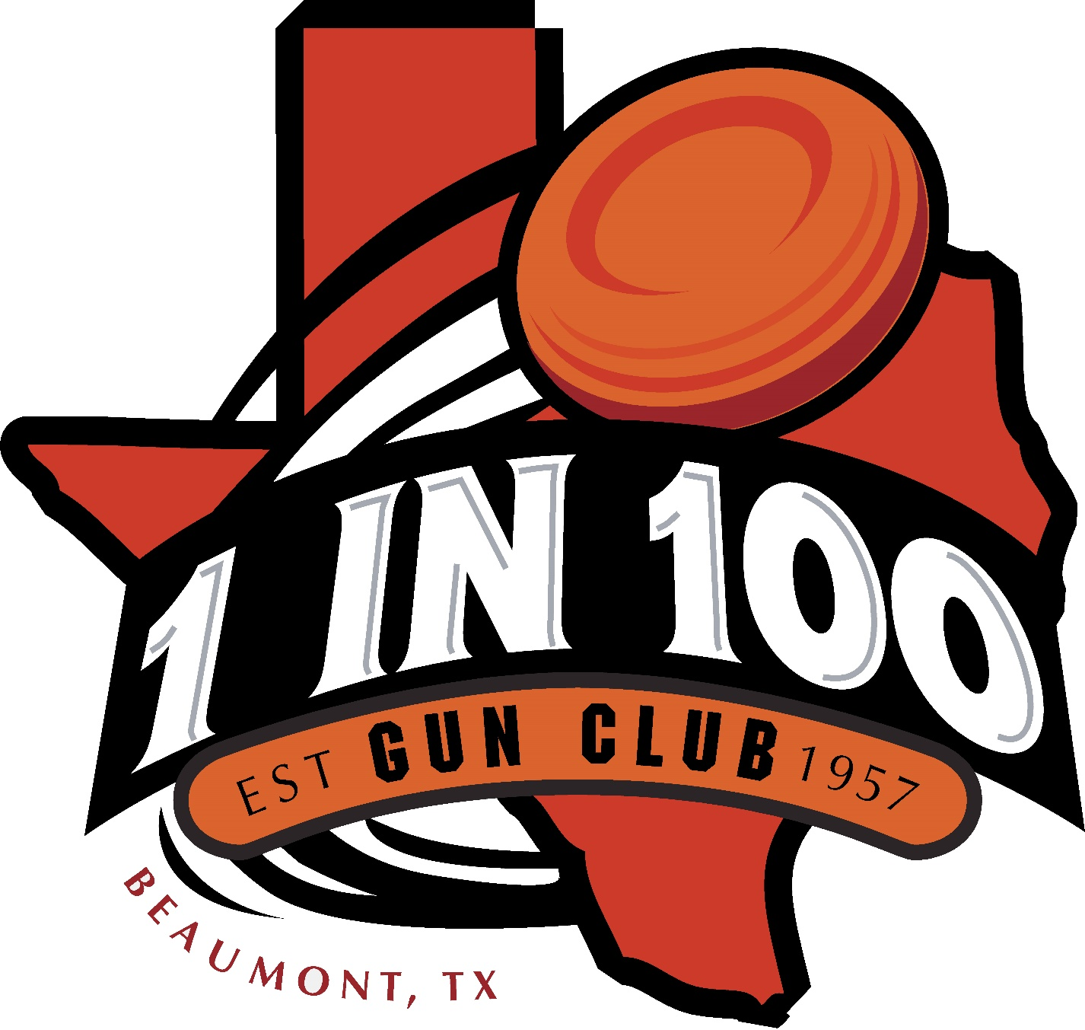
1 In 100 Gun Club
1228 FM 421 RD Lumberton, Tx 77657
Saturday, August 22nd, 2020
(9am – 1pm)

100 Total Targets - $50.00
(99 – 3 Bird Targets : 1 – Longshot Target)
( PULL YOUR OWN)
Lunch – $5.00
Links – Boudin – Soda/Water

Targets will be thrown as the following format:
AB – True : C on/report of First Shot
(3 Bird -- C will be thrown when you shoot the first shot!)
(Longshot Bird – Full use of gun, 3 shots at the 1 target!)

BRING FAMILY, FRIENDS, COWORKERS AND YOUR BOSS AND
COME ON OUT FOR A GREAT TIME AND FUN MEMORIES!!!

If you have any questions, contact Megan Carter or Jace Pendino at the Gun Club Office!!
Phone: (409) 755-6648 E-mail: 1in100gunclub@gmail.com

